Agile Development and Process Management
LAB FAT
S Dhanush Kumar

Folder Structure:
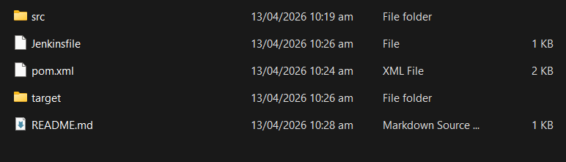
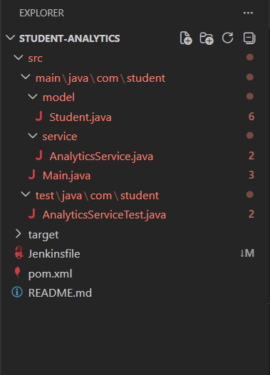

src/main/java/com/student/model/Student.java

package com.student.model;

public class Student {
private String name;
private int catMarks;
private int assignmentMarks;
private int fatMarks;

public Student(String name, int catMarks, int assignmentMarks, int fatMarks) {
this.name = name;
this.catMarks = catMarks;
this.assignmentMarks = assignmentMarks;
this.fatMarks = fatMarks;
}

public String getName() {
return name;
}

public int getTotalMarks() {
return catMarks + assignmentMarks + fatMarks;
}

public double getGPA() {
int total = getTotalMarks();

if (total >= 90) return 10.0;
else if (total >= 80) return 9.0;
else if (total >= 70) return 8.0;
else if (total >= 60) return 7.0;
else if (total >= 50) return 6.0;
else return 5.0;
}

public String getGrade() {
int total = getTotalMarks();

if (total >= 90) return “A+”;
else if (total >= 80) return “A”;
else if (total >= 70) return “B”;
else if (total >= 60) return “C”;
else if (total >= 50) return “D”;
else return “F”;
}
}

Src/main/java/com/student/service/AnalyticsService.java

package com.student.service;

import com.student.model.Student;
import java.util.List;

public class AnalyticsService {

public Student findTopper(List<Student> students) {
Student topper = students.get(0);

for (Student s : students) {
if (s.getTotalMarks() > topper.getTotalMarks()) {
topper = s;
}
}
return topper;
}

public double calculateAverageMarks(List<Student> students) {
int sum = 0;

for (Student s : students) {
sum += s.getTotalMarks();
}

return (double) sum / students.size();
}

public void printReport(List<Student> students) {
System.out.println("\n---- Student Report ----");

for (Student s : students) {
System.out.println(
s.getName() + " | Total: " + s.getTotalMarks() +
" | GPA: " + s.getGPA() +
" | Grade: " + s.getGrade()
);
}
}
}

src/main/java/com/student/Main.java

package com.student;

import com.student.model.Student;
import com.student.service.AnalyticsService;

import java.util.ArrayList;
import java.util.List;

public class Main {

public static void main(String[] args) {

List<Student> students = new ArrayList<>();

// Hardcoded data (for Jenkins compatibility)
students.add(new Student("A", 25, 18, 45));
students.add(new Student("B", 20, 15, 40));
students.add(new Student("C", 28, 19, 48));
students.add(new Student("D", 22, 17, 42));
students.add(new Student("E", 26, 18, 46));

AnalyticsService service = new AnalyticsService();

service.printReport(students);

Student topper = service.findTopper(students);
System.out.println("\nTopper: " + topper.getName());

double avg = service.calculateAverageMarks(students);
System.out.println("Average Marks: " + avg);
}
}

src/test/java/com/student/AnalyticsServiceTest.java

package com.student;

import com.student.model.Student;
import com.student.service.AnalyticsService;
import org.junit.jupiter.api.Test;

import java.util.Arrays;
import java.util.List;

import static org.junit.jupiter.api.Assertions.*;

public class AnalyticsServiceTest {

@Test
public void testTopper() {
List<Student> students = Arrays.asList(
new Student(“A”, 20, 15, 40),
new Student(“B”, 25, 18, 45),
new Student(“C”, 10, 10, 20)
);

AnalyticsService service = new AnalyticsService();
Student topper = service.findTopper(students);

assertEquals(“B”, topper.getName());
}

@Test
public void testAverage() {
List<Student> students = Arrays.asList(
new Student(“A”, 20, 15, 40),
new Student(“B”, 25, 18, 45)
);

AnalyticsService service = new AnalyticsService();
double avg = service.calculateAverageMarks(students);

assertTrue(avg > 0);
}
}

pom.xml

<project xmlns="http://maven.apache.org/POM/4.0.0"
xmlns:xsi="http://www.w3.org/2001/XMLSchema-instance"
xsi:schemaLocation="http://maven.apache.org/POM/4.0.0
http://maven.apache.org/xsd/maven-4.0.0.xsd">

<modelVersion>4.0.0</modelVersion>

<groupId>com.student</groupId>
<artifactId>student-analytics</artifactId>
<version>1.0-SNAPSHOT</version>

<properties>
<maven.compiler.source>17</maven.compiler.source>
<maven.compiler.target>17</maven.compiler.target>
</properties>

<dependencies>
<dependency>
<groupId>org.junit.jupiter</groupId>
<artifactId>junit-jupiter</artifactId>
<version>5.9.3</version>
<scope>test</scope>
</dependency>
</dependencies>

<build>
<plugins>
<plugin>
<groupId>org.apache.maven.plugins</groupId>
<artifactId>maven-surefire-plugin</artifactId>
<version>3.0.0-M7</version>
</plugin>
</plugins>
</build>

</project>

Jenkinsfile

pipeline {
agent any

tools {
maven 'Maven'
}

stages {

stage('Checkout') {
steps {
git branch: 'main', url: 'https://github.com/gunatejakp/student-analytics.git'
}
}

stage('Build') {
steps {
bat 'mvn clean package'
}
}

stage('Test') {
steps {
bat 'mvn test'
}
}
}

post {
success {
echo 'Build Successful 🎉'
}
failure {
echo 'Build Failed ❌'
}
}
}

Screenshots:

Maven Build Successfully
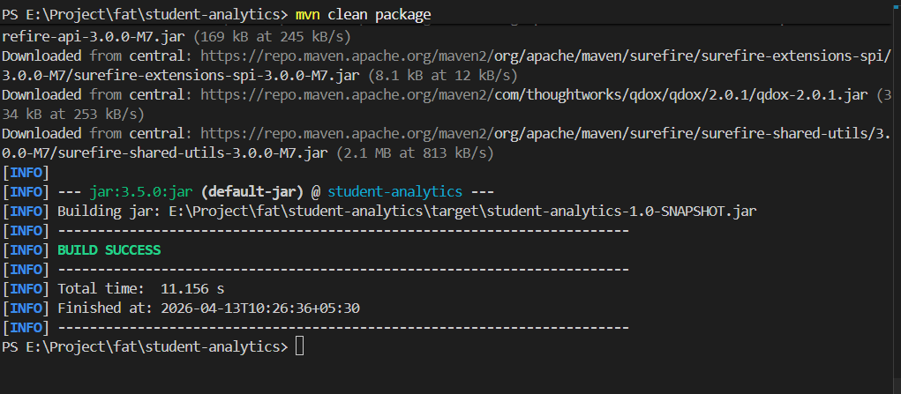

Cloning Repo in Github
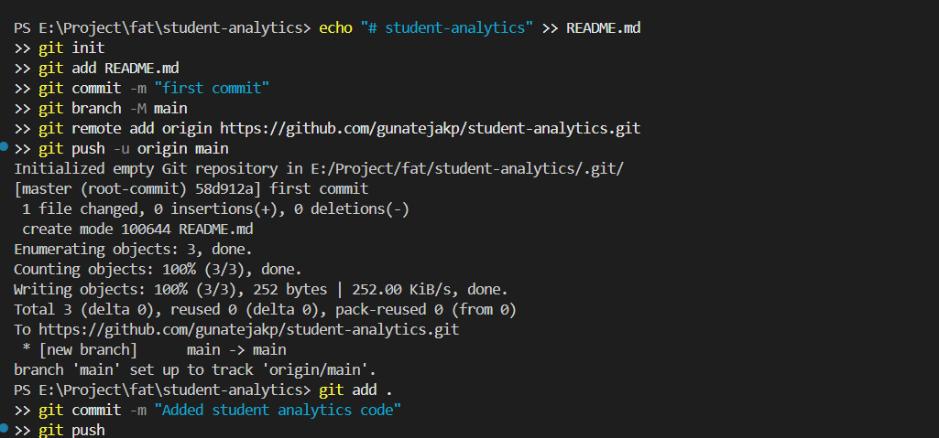

After Cloning the GitHub Repo is:
Folder Structure:

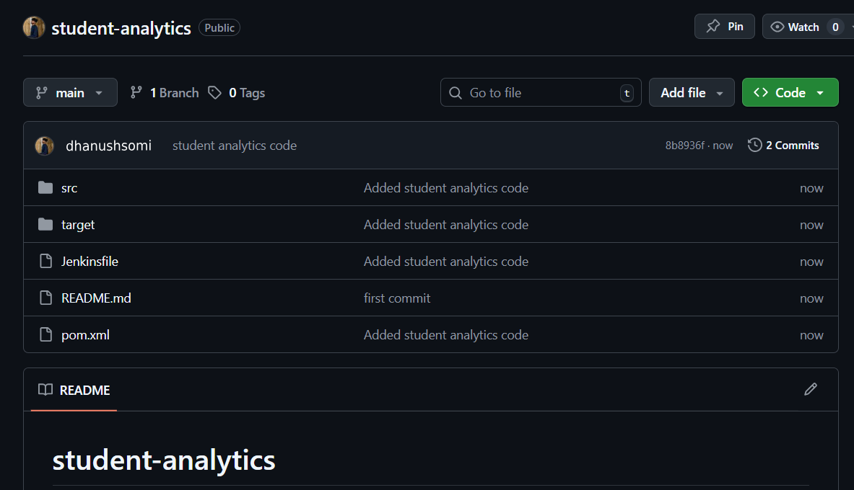

Pipeline Build Finished
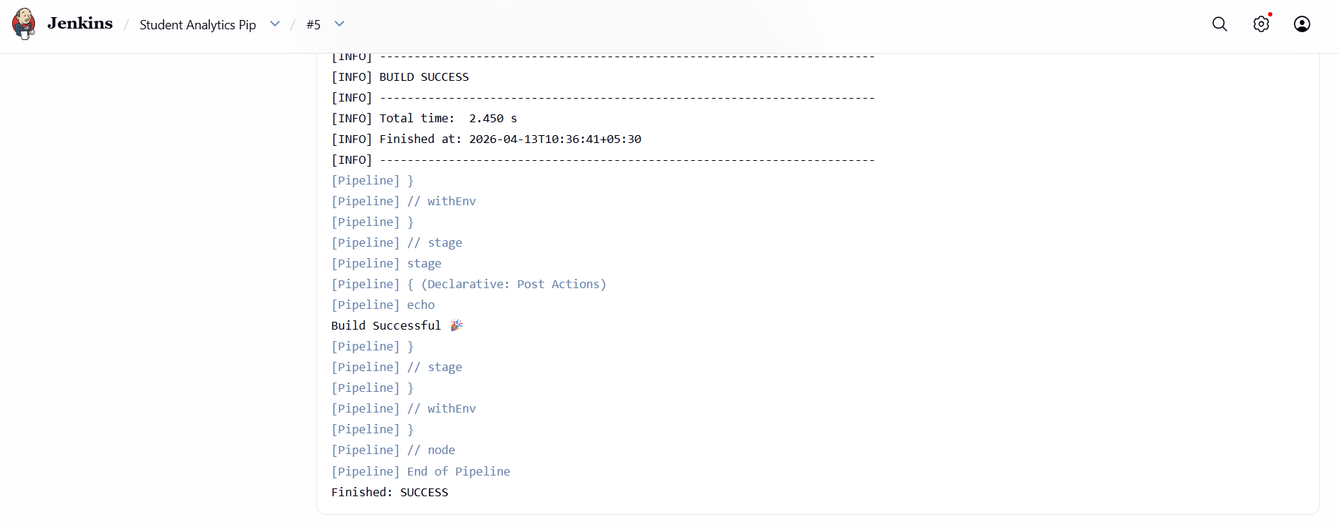

Pipeline Overview
